# **Name: Abdurrahman Qureshi**

# **Roll No: 210451**

Practical No: 4

**1) Greatest Of Three Integers**

**CODE:**

Module GreatestOfThree

Sub Main()

Dim A As Integer

Dim B As Integer

Dim C As Integer

A = InputBox("Enter Value For A:")

B = InputBox("Enter Value For B:")

C = InputBox("Enter Value For C:")

If A > B Then

If A > C Then

MsgBox("A = " & A & " is the Greatest")

Else

MsgBox("C = " & C & " is the Greatest")

End If

ElseIf B > C Then

MsgBox("B = " & B & " is the Greatest")

Else

MsgBox("C = " & C & " is the Greatest")

End If

End Sub

End Module

**OUTPUT:**

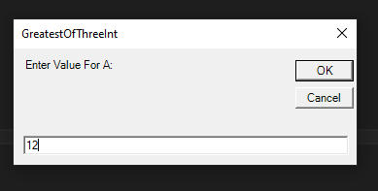

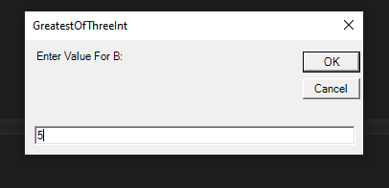

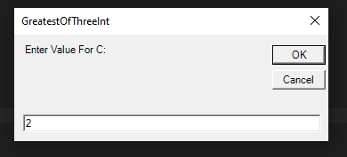

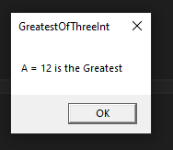

**2) Leap Year**

**CODE:**

Module Module1

Sub Main()

Dim nyear As Integer

nyear = InputBox("210451 - Enter any Year")

If (nyear Mod 400 = 0) Then

MsgBox("Its a leap year")

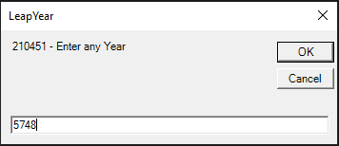

ElseIf (nyear Mod 100 = 0) Then

MsgBox("Not a leap year")

ElseIf (nyear Mod 4 = 0) Then

MsgBox("Its a leap year")

Else

MsgBox("Not a leap year")

End If

End Sub

End Module

**OUTPUT:**



**3) Even or Odd**

**CODE:**

Module Module1

Sub Main()

Dim userN As Integer

userN = InputBox("Enter any number to check:")

If userN Mod 2 = 0 Then

Console.WriteLine("The entered number " & userN & " is an Even number")

Else

Console.WriteLine("The entered number " & userN & " is an Odd number")

End If

Console.ReadLine()

End Sub

End Module

**OUTPUT:**

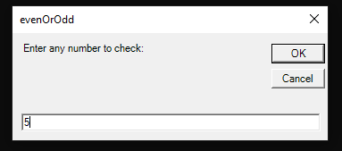

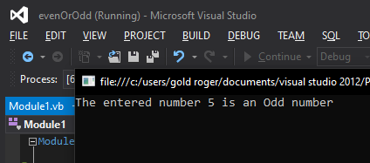

**4) Number of week day**

**CODE:**

Module Module1

Sub Main()

Dim userInputDay As Integer

userInputDay = InputBox("Enter a number for the week day from 1 - 7")

If userInputDay = 1 Then

Console.WriteLine("The entered number " & userInputDay & " belongs to Monday")

ElseIf userInputDay = 2 Then

Console.WriteLine("The entered number " & userInputDay & " belongs to Tuesday")

ElseIf userInputDay = 3 Then

Console.WriteLine("The entered number " & userInputDay & " belongs to Wednesday")

ElseIf userInputDay = 4 Then

Console.WriteLine("The entered number " & userInputDay & " belongs to Thurday")

ElseIf userInputDay = 5 Then

Console.WriteLine("The entered number " & userInputDay & " belongs to Friday")

ElseIf userInputDay = 6 Then

Console.WriteLine("The entered number " & userInputDay & " belongs to Saturday")

ElseIf userInputDay = 7 Then

Console.WriteLine("The entered number " & userInputDay & " belongs to Sunday")

End If

Console.ReadLine()

End Sub

End Module

**OUTPUT:**

